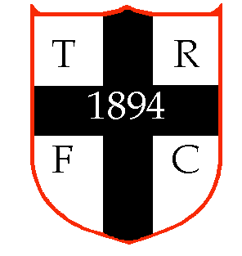 | Toddington Rovers Football Club  Medical Conditions Form  Season 2022 – 2023 | 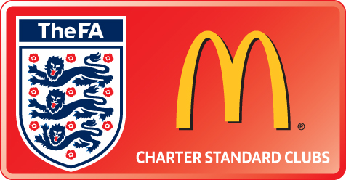

This form is to be completed by the Club Member and the Club Member’s Parent/Guardian (if the Club Member is aged below 18). Any medical condition or allergy that may affect the Member’s ability to train and represent the Club should be noted below. If any medication is regularly used by the Member, it should also be noted below.

Member’s Name
TRFC Team
TRFC Team Manager
Parent/Guardian’s Name
Parent/Guardian’s
Emergency Contact Details

Condition
Visible Signs
Medication/
Corrective Action

Condition
Visible Signs
Medication/
Corrective Action

Any further conditions should be noted overleaf

…………………………….. …………………………….. ……………………….. ……….
Signed (Player) Signed (Parent/Guardian) Signed (Manager) Date

WHEN COMPLETE, THIS FORM SHOULD BE PASSED TO THE CLUB CHILD WELFARE OFFICER, WHO WILL RETAIN THIS INFORMATION CONFIDENTIALLY AND ENSURE THAT ONLY THOSE WHO NEED TO KNOW ARE MADE AWARE OF THESE DETAILS.

